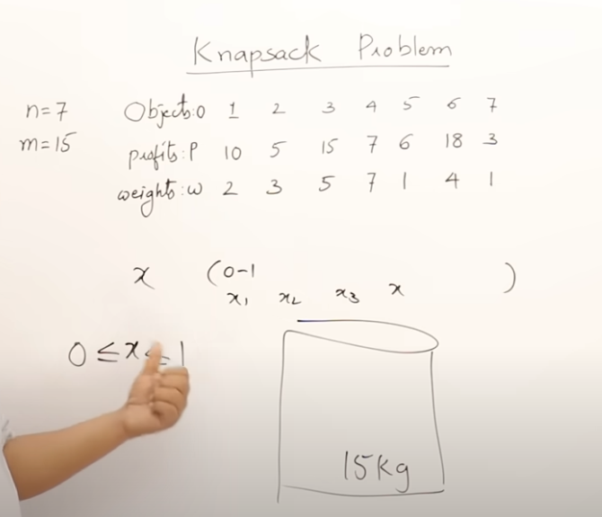

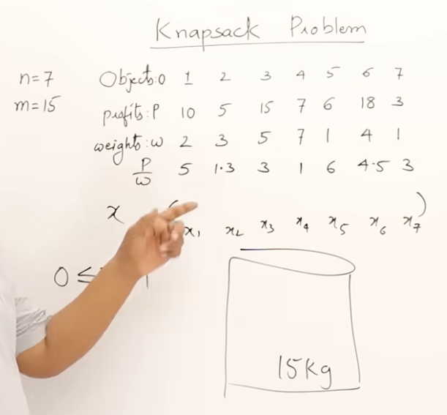 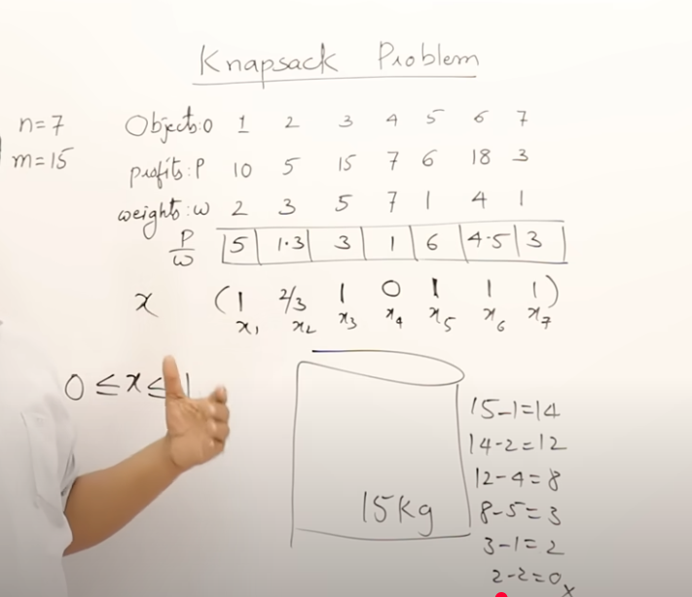 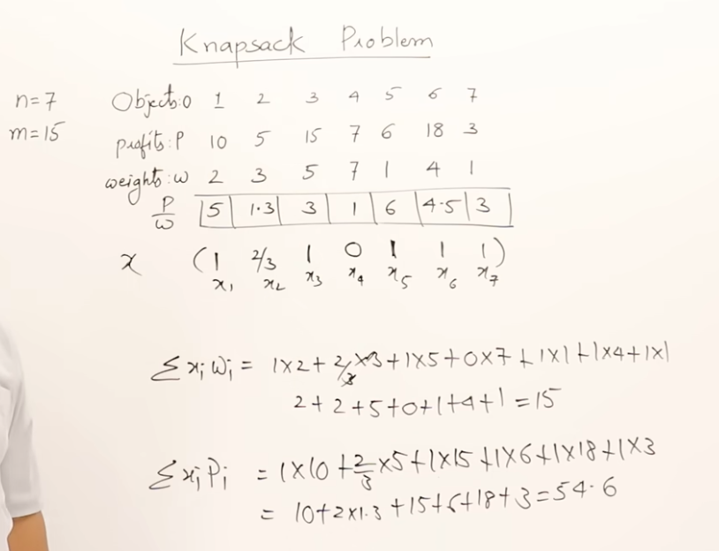

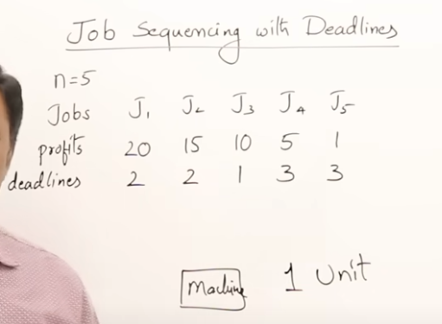 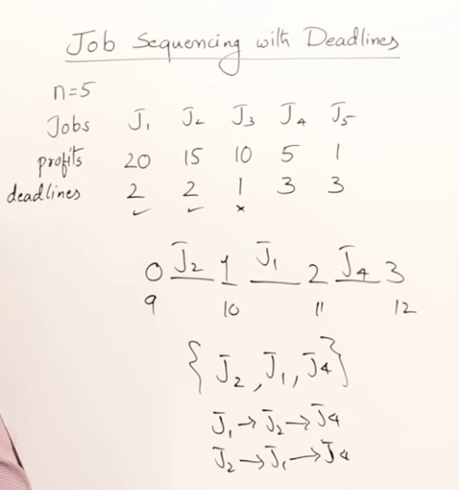  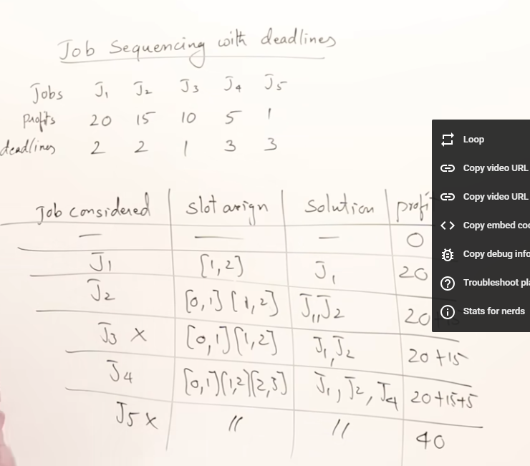 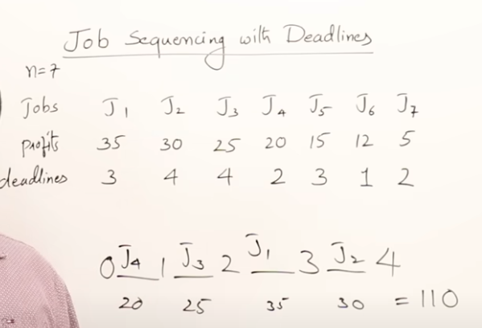

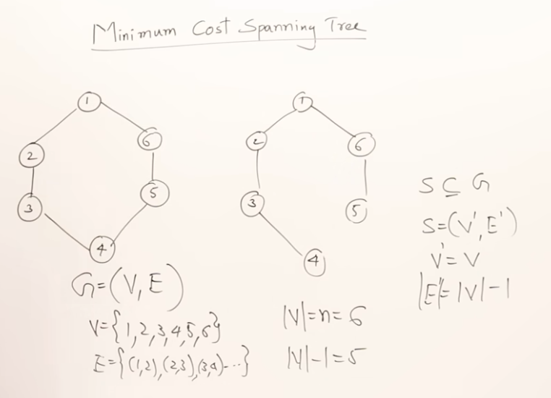 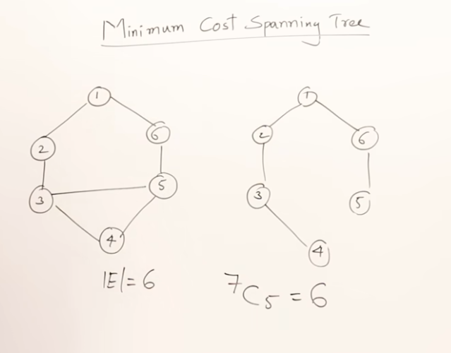 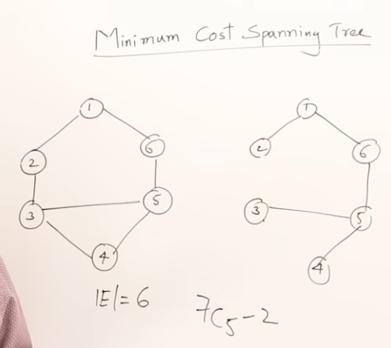 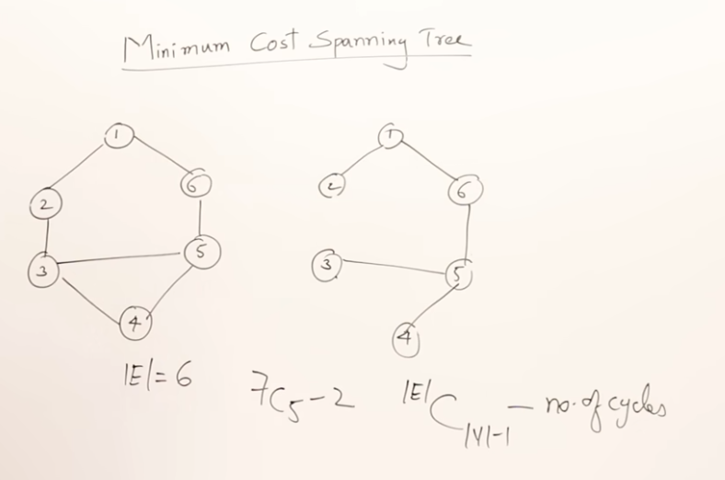 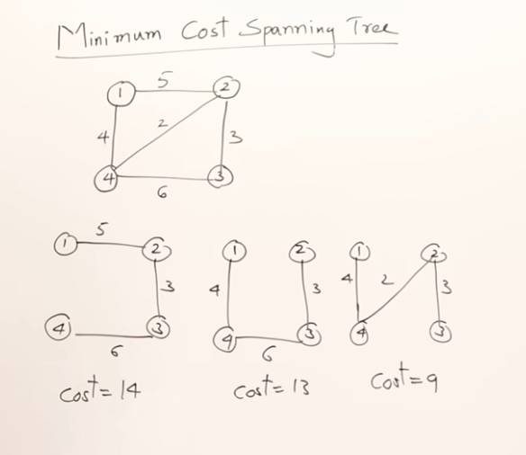 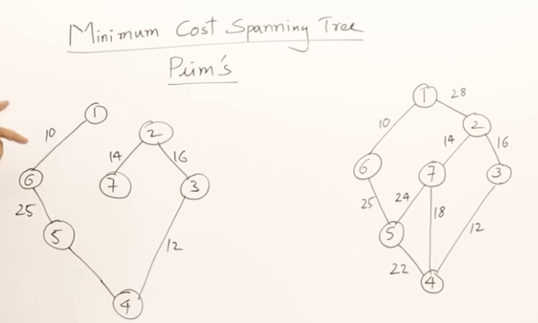 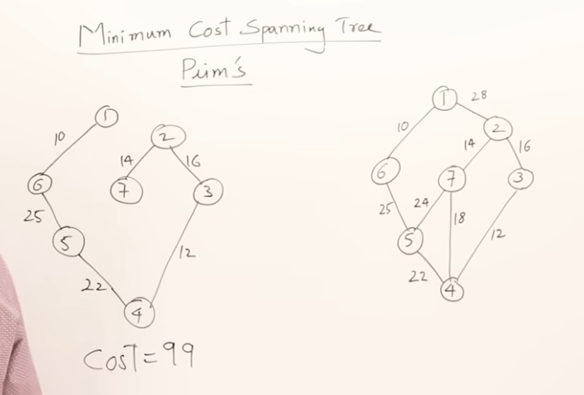 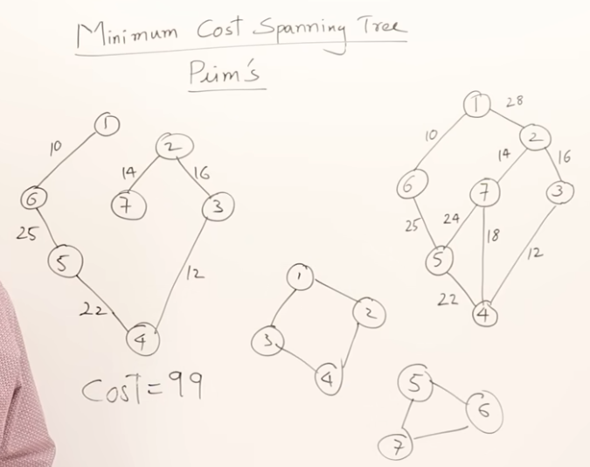

#include <iostream>

using namespace std;

#define INF 999999

int main() {

int n; // number of vertices

cout << "Enter number of vertices: ";

cin >> n;

int cost[20][20]; // adjacency matrix

cout << "Enter adjacency matrix (0 if no edge):\n";

for (int i = 0; i < n; i++) {

for (int j = 0; j < n; j++) {

cin >> cost[i][j];

if (cost[i][j] == 0 && i != j) {

cost[i][j] = INF; // no edge = INF

}

}

}

int visited[20] = {0};

visited[0] = 1; // start from node 0

int edgeCount = 0, totalCost = 0;

cout << "\nEdges in MST:\n";

while (edgeCount < n - 1) {

int u = -1, v = -1, minCost = INF;

for (int i = 0; i < n; i++) {

if (visited[i]) {

for (int j = 0; j < n; j++) {

if (!visited[j] && cost[i][j] < minCost) {

minCost = cost[i][j];

u = i;

v = j;

}

}

}

}

visited[v] = 1;

totalCost += minCost;

cout << u << " - " << v << " : " << minCost << "\n";

edgeCount++;

}

cout << "Total cost of MST = " << totalCost << "\n";

return 0;

}